**DBS201 Final Assignment**

**Course: DBS201A**

**Members:**

**Muchtar Salimov**

**Ziyi Shi**

**Yuansheng Lu**

**Brendan Hung**

**Date of Submission: 8/4/2017**

**User View 1:**

UNF:

SERVICEINVOICE [ServiceInvoiceNo, ServiceInvoiceDate, WorkTeam, CustomerNo, CustomerName, CustomerAddress, ((EquipmentID, EquipmentDescription), ServiceCode, ServiceDescription, HourlyCharge, WorkDuration) ]

1NF:

SERVICEINVOICE[ServiceInvoiceNo, ServiceCode, EquipmentID, ServiceInvoiceDate, WorkTeam, CustomerNo, CustomerName, CustomerAddress, EquipmentDescription, ServiceDescription, HourlyCharge, WorkDuration]

2NF:

SERVICEINVOICE [ ServiceInvoiceNo, ServiceInvoiceDate, WorkTeam, CustomerNo, CustomerName, CustomerAddress]

SERVICE [ServiceCode, ServiceDescription, HourlyCharge]

EQUIPMENTNEEDED[ServiceCode, EquipmentID]

EQUIPMENT[EquipmentID, EquipmentDescription]

SERVICEDURATION [ ServiceInvoiceNo, ServiceCode, WorkDuration]

3NF:

SERVICEINVOICE [ ServiceInvoiceNo (PK), ServiceInvoiceDate, WorkTeam, CustomerNo (FK) ]

CUSTOMER [CustomerNo (PK), CustomerName, CustomerAddress ]

SERVICE [ServiceCode (PK), ServiceDescription, HourlyCharge ]

EQUIPMENTNEEDED[ServiceCode (FK), EquipmentID (FK)]

EQUIPMENT[EquipmentID (PK), EquipmentDescription]

SERVICEDURATION [ ServiceInvoiceNo (FK), ServiceCode (FK), WorkDuration]

**User View2:**

UNF:

TEAM [TeamNo, TeamDescription, (EmployeePosition, EmployeeName, EmployeeID, OHIPNo, EmployeePhone, EmployeeStartDate, (SkillID, SkillDescription))]

1NF:

TEAM [TeamNo, EmployeeID, SkillID, TeamDescription, EmployeePosition, EmployeeName, OHIPNo, EmployeePhone, EmployeeStartDate, SkillDescription]

2NF:

TEAM [TeamNo, TeamDescription]

EMPLOYEE [EmployeeID, EmployeePosition, EmployeeName, OHIPNo, EmployeePhone, EmployeeStartDate, TeamNo]

EmployeeSkill[EmployeeID , SkillID ]

SKILL[SkillID, SkillDescription]

3NF:

TEAM [TeamNo (PK), TeamDescription]

EMPLOYEE [EmployeeID, EmployeeName, EmployeePosition, EmployeeStartDate, EmployeePhone, OHIPNo, TeamNo (FK)]

EMPLOYEESKILL[ EmployeeID (FK) , SkillID (FK) ]

SKILL[SkillID (PK), SkillDescription]

**User View 3:**

UNF:

SALESINVOICE[SalesInvoiceId, SalesInvoiceDate, SalesAssistantNo, SalesAssistantName, CustomerNo, (ProductId, ClassCode, ProductDescription, QuantityOrdered)]

1NF:

SALESINVOICE[SalesInvoiceId, ProductId, ProductDescription, CustomerNo, ClassCode, SalesInvoiceDate, SalesAssistantNo, SalesAssistantName, QuantityOrdered]

2NF:

SALESINVOICE[SalesInvoiceID, SalesInvoiceDate, SalesAssistantNo, SalesAssistantName, CustomerNo]

PRODUCT[ProductId, ClassCode, ProductDescription]

PRODUCTSALES[SalesInvoiceID, ProductId, QuantityOrdered]

3NF:

SALESINVOICE[SalesInvoiceID (PK), SalesInvoiceDate, SalesAssistantNo (FK), CustomerNo]

PRODUCT[ProductId (PK), ClassCode, ProductDescription]

PRODUCTSALES[SalesInvoiceID (FK), ProductId(FK), QuantityOrdered]

SALESASSISTANT[ SalesAssistantNo (PK), SalesAssistantName]

**User View4:**

UNF:

PRODUCT[ProductID , ProductDescription, ProductCost, ClassCode, ClassDescription, Markup]

1NF:

PRODUCT[ProductID, ProductDescription, ProductCost, ClassCode, ClassDescription, Markup]

2NF:

PRODUCT[ProductID, ProductDescription, ProductCost, ClassCode, ClassDescription, Markup]

3NF:

PRODUCT[ProductID (PK), ProductDescription, ProductCost, ClassCode (FK)]

CLASS[ClassCode (PK), ClassDescription, Markup]

**User View 5:**

UNF:

PRODUCT[ProductID, ProductDescription, StockQuantity, AisleNo, Supplier]

1NF:

PRODUCT[ProductID, ProductDescription, StockQuantity, AisleNo, Supplier]

2NF:

PRODUCT[ProductID, ProductDescription, StockQuantity, AisleNo, Supplier]

3NF:

PRODUCT[ProductID (PK), ProductDescription, StockQuantity, AisleNo, Supplier]

**User View 1 3NF:**

SERVICEINVOICE [ ServiceInvoiceNo (PK), ServiceInvoiceDate, WorkTeam, CustomerNo (FK) ]

CUSTOMER [CustomerNo (PK), CustomerName, CustomerAddress ]

SERVICE [ServiceCode (PK), ServiceDescription, HourlyCharge ]

EQUIPMENTNEEDED[ServiceCode (FK), EquipmentID (FK)]

EQUIPMENT[EquipmentID (PK), EquipmentDescription]

SERVICEDURATION [ ServiceInvoiceNo (FK), ServiceCode (FK), WorkDuration]

**User View 2 3NF:**

TEAM [TeamNo (PK), TeamDescription]

EMPLOYEE [EmployeeID, EmployeeName, EmployeePosition, EmployeeStartDate, EmployeePhone, OHIPNo, TeamNo (FK)]

EMPLOYEESKILL[ EmployeeID (FK) , SkillID (FK) ]

SKILL[SkillID (PK), SkillDescription]

**User View 3 3NF:**

SALESINVOICE[SalesInvoiceID (PK), SalesInvoiceDate, SalesAssistantNo (FK), CustomerNo]

PRODUCT[ProductId (PK), ClassCode, ProductDescription]

PRODUCTSALES[SalesInvoiceID (FK), ProductId(FK), QuantityOrdered]

SALESASSISTANT[ SalesAssistantNo (PK), SalesAssistantName]

**User View 4 3NF:**

PRODUCT[ProductID (PK), ProductDescription, ProductCost, ClassCode (FK)]

CLASS[ClassCode (PK), ClassDescription, Markup]

**User View 5 3NF:**

PRODUCT[ProductID (PK), ProductDescription, StockQuantity, AisleNo, Supplier]

**Merging**

SERVICEINVOICE[ServiceInvoiceNo (PK), ServiceInvoiceDate, TeamNo (FK), CustomerNo (FK)]

CUSTOMER[CustomerNo (PK), CustomerName, AddressID (FK)]

ADDRESS[AddressID (PK), StreetNo, StreetName, City, PostalCode]

SERVICE[ServiceCode (PK), ServiceDescription, HourlyCharge]

SERVICEDURATION[ServiceInvoiceNo (FK), ServiceCode (FK), WorkDuration]

EQUIPMENT[EquipmentID (PK), EquipmentDescription]

EQUIPMENTNEEDED[ServiceCode (FK), EquipmentID (FK)]

TEAM[TeamNo (PK), TeamDescription]

EMPLOYEE[EmployeeID (PK),EmployeeName, EmployeePosition, EmployeeStartDate, EmployeePhone, OHIPNo, TeamNo (FK)]

EMPLOYEESKILL[EmployeeID (FK) , SkillID (FK) ]

SKILL[SkillID, SkillDescription]

SALESINVOICE[SalesInvoiceId (PK), SalesInvoiceDate, SalesAssistantNo (FK), CustomerNo (FK)]

PRODUCT[ProductId (PK), ProductDesription, StockQuantity, AisleNo, Supplier, ClassCode (FK)]

SALESPRODUCT[SalesInvoidId (FK), ProductID (FK), QuantityOrdered]

ASSISTANT[SalesAssistantNo (PK), SalesAssistantName]

CLASS[ClassCode (PK), ClassDescription, Markup]

**VIEWS:**

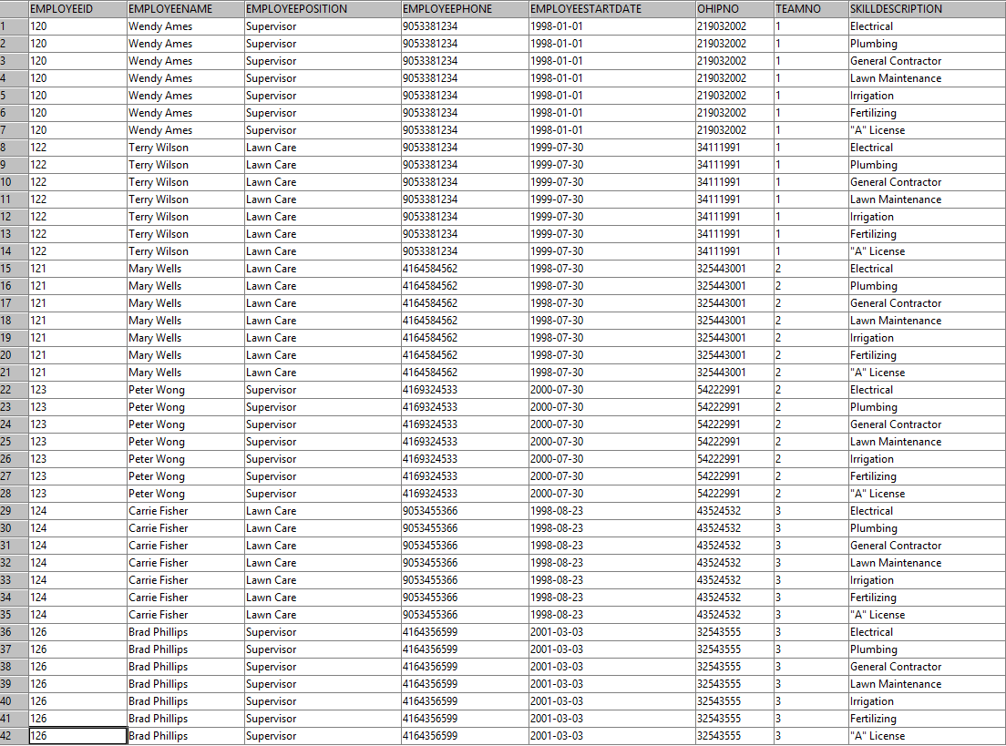

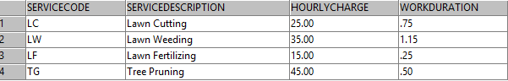

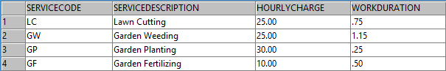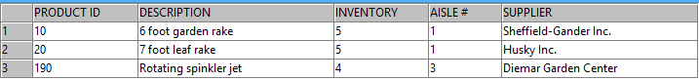

**Constraints:**

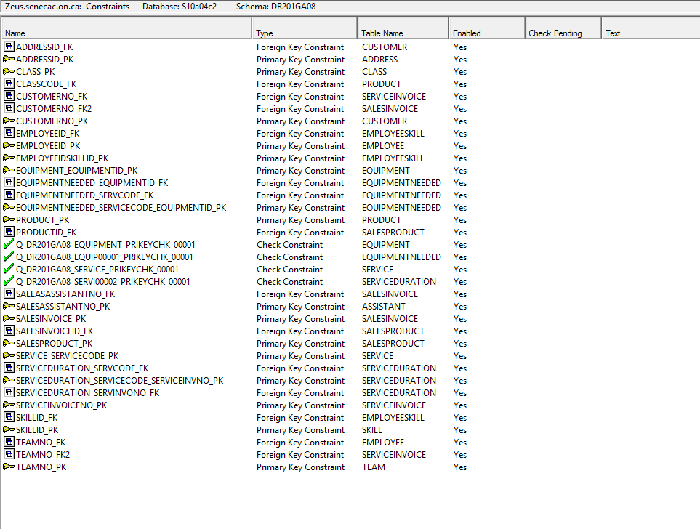

Student Assignment Submission Form

I/we declare that the attached assignment is my/our own work in accordance with the Seneca Academic Policy. No part of this assignment has been copied manually or electronically from any other source (including web sites) **or distributed to other students**

Name(s) Signature

1_____________________________________________________________________

2_____________________________________________________________________

3_____________________________________________________________________

4_____________________________________________________________________